- Introduction

1. Introduction
The Internet of Things (IoT) is a part of the Future Internet paradigm, which rapidly changes the development of technologies as well as provision of services over different communication networks. The capability of objects (like physical or virtual things) to identify and communicate with each other at any time‐evolving communication technologies gives the possibility to provide advanced services over global infrastructure (as Internet) in different areas of everyday life [1]. The interconnection of smart objects and its interoperability with global communications serve as a main idea incorporated in Internet of Things systems. Wireless sensor network (WSN) plays a main role in the IoT system as its components include sensing, acquiring of data, heterogeneous connectivity, data processing, etc. Mobile ad‐hoc network (MANET) is a wireless, multi‐hop, self‐configuring network. Its each node operates as an end system and/or a router for other nodes in the network and is closely related to WSNs. The interaction between MANET and Internet of Things opens new ways for provision of services in smart environments and challenging issues in its networking aspects as well.

One of the important factors in such MANET‐IoT systems is the energy balancing over nodes, since the IoT system is based mostly on many different wireless sensors and MANET protocols focus on selecting the shortest and efficient paths for transactions. A proper utilization of sensor's battery power is a significant key in maintaining network connectivity of a multi‐hop wireless network. Due to this, many researchers are focusing on designing energy efficient routing protocols that prolong such network lifetime. Wireless network protocols like MANET cannot be used directly due to resource constraints of sensors’ nodes, computational speed, human interface with node's devices and density of nodes in network. Therefore, it is a need of composite solution for routing over MANET‐IoT networks, which can use efficiently residual energy of nodes and extend the network's lifetime.

In this chapter, the authors propose an algorithm of energy efficient and safe‐weighted clustering routing for the mobile IoT system using a combination of MANET and WSN routing principles. Clustering is one method of making routing less complex, and for some sensor networks, more energy efficient. Such combination of MANET and WSN routing principles is able to increase the lifetime of sensors in the overall mobile Internet of Things system. It is important to decide how many cluster heads (CHs) are needed and which of the sensor nodes are going to act as cluster heads. MANET network nodes were chosen as a cluster head and a proactive routing protocol was used in such a way that it is possible to control and update a table of information about the state of the network. Nodes that rapidly lose its energy or that are left with low energy were identified and their workloads were limited for transactions. All investigations for the selection of a routing path over the MANET‐IoT system were performed by using the MATLAB simulation platform.

This research work provides important key insights into the combination of MANET and WSN routing principles by increasing the lifetime of sensors in the overall Internet of Things system. The solution of routing optimization with an effective and efficient approach to energy consumption in the global MANET‐IoT system is presented as main result of this work, which can help in accessibility and provision of services for a longer period of time over global Future Internet infrastructure.

Mobile ad‐hoc network (MANET)
The mobile ad‐hoc networks (MANETS) are autonomously self‐organized networks without fixed topology. In such a network, each node acts as both router and hosts at the same time. All network nodes are equivalent to each other and can move out or join in the network freely. The mobile nodes that are in the radio range of each other can directly communicate and transfer the necessary information. All network nodes have a wireless interface to communicate with another node in the range. This kind of network is fully distributed and can work at any place without the help of any fixed infrastructure as access points or base stations

It can be assigned two multiple ad‐hoc network types: (a) mobile ad‐hoc network (MANET) and (b) mobile ad‐hoc sensor network. A mobile ad‐hoc sensor network has much wider sequences of

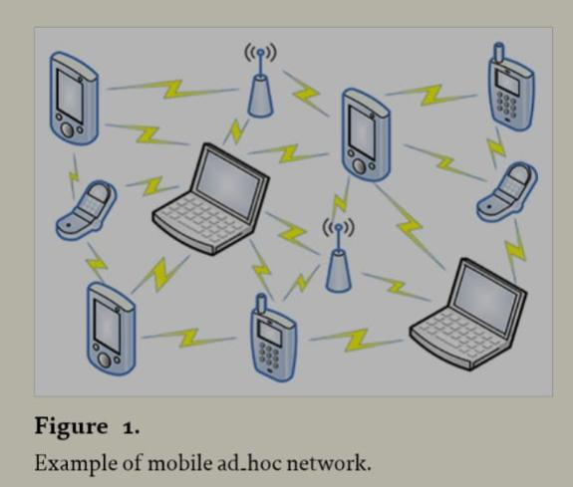
operational, and at the same time needs a less complex setup procedure compared to typical sensor networks, which communicate directly with the centralized controller [3]. There are six main characteristics of MANETs [2]: distributed operation; multi‐hop routing, autonomous terminal, dynamic topology, lightweight terminals, and shared physical medium.

manet routing protocols can be categorized into three types:

topology‐based routing

the routing types [3] are: (a) proactive routing protocols (routing table‐based), (b) reactive routing protocols (demand based) are presented in figure 2 and (c) hybrid routing protocols. these protocols are the combination of proactive and reactive routing protocols. one of them is zrp (zone routing protocol).
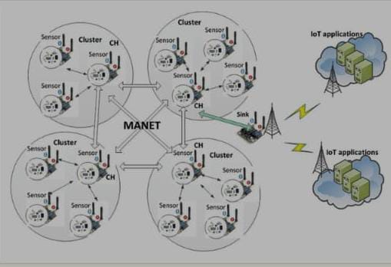

To make routing decision, location‐based routing uses the actual position of nodes in any area. Location information can be obtained, for example, using global positioning system (GPS). Location‐aided routing (LAR) protocol is an example of location‐based routing.

Energy awareness‐based routing

Each node in the network supports multiple entries of routing in routing tables. For choosing optimal route in the wireless medium, routing assessing power levels of network nodes is available. In this case, routing table corresponding to the power level of nodes and maintained by transferring hello messages in between nodes at the power level. The number of entries in routing table of nodes is corresponding to the number of nodes reachable by using the power level. Thus, the number of entries in routing tables gives the total number of network nodes

Sensors establish and maintain routes can proactively or reactively. Proactive protocols periodically monitor peer connectivity to ensure the ready availability of any path among active nodes. Sensors advertise their routing state to the entire network to maintain a common or partially complete topology of the network. Reactive protocols establish paths only upon request. For MANET sensor network in the IoT system information routing we use combination of two routing principles: OLSR (optimized link‐state retrieval) and LEACH (low energy adaptive clustering hierarchy).

Clustering network is efficient and scalable way to organize WSN. Clustering is the method by which sensor nodes in a network organize themselves into hierarchical structures. By doing this, sensor nodes can use battery power more efficiently. A cluster head (CH) is responsible for conveying any information gathered by the nodes in its cluster and may aggregate and compress the data before transmitting it to the sink.

LEACH selects cluster head randomly among all nodes completely. Using our propose algorithm of energy efficient and safe‐weighted clustering routing for the mobile IoT system, the cluster head is a node that in actual time has more energy than the threshold value.

The sensing range of a sensor is the maximum distance that a sensor can sense. To form clusters, sensor nodes first elect a CH for each cluster. Nodes in the WSN which are not CHs find the closest CH within the range and become cluster members. The nodes in a cluster only communicate with one another and the CH. The number of CH can be different for every network topology. The propose algorithm implementing dynamical CH rotation that allows us to distribute the workload CH across the mobile MANET‐IoT system and extend overall lifetime of our system.

The MANET‐IoT network with a cluster topology is shown in Figure 7. Sensors are grouped into clusters and individual sensors sense data and transmit to cluster heads (CH). Cluster heads aggregate this data and then forward, depending on the tree structure, to the base station or sink node. We assume that each sensor senses L bits and transmit to CH.

Typical MANET nodes are Laptops, PDAs, Pocket PCs, Cellular Phones, Internet Mobil Phones, Palmtops or any other mobile wireless devices. These devices are typically lightweight and battery operated

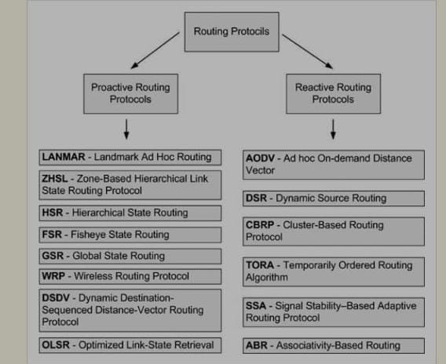

you for visiting my project file.

